Finding IP Range:

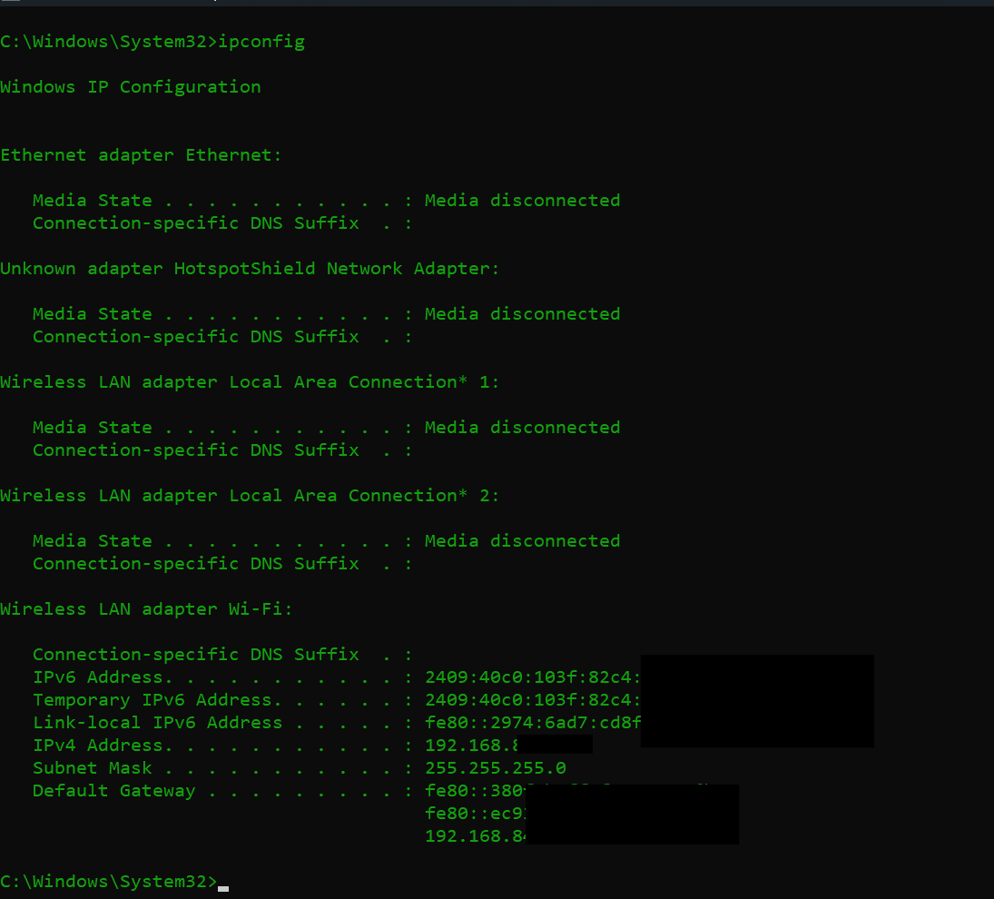

IPV4: 192.168.xx.xxx

Submet: 255.255.255.0 -> CIDR: 24

NMAP Result:

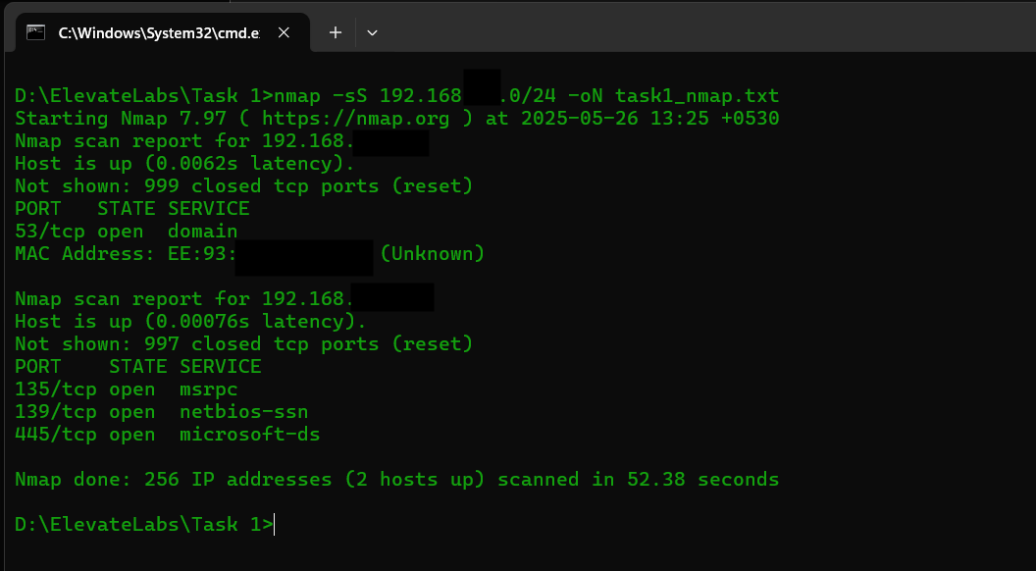

WIRESHARK RESULT:

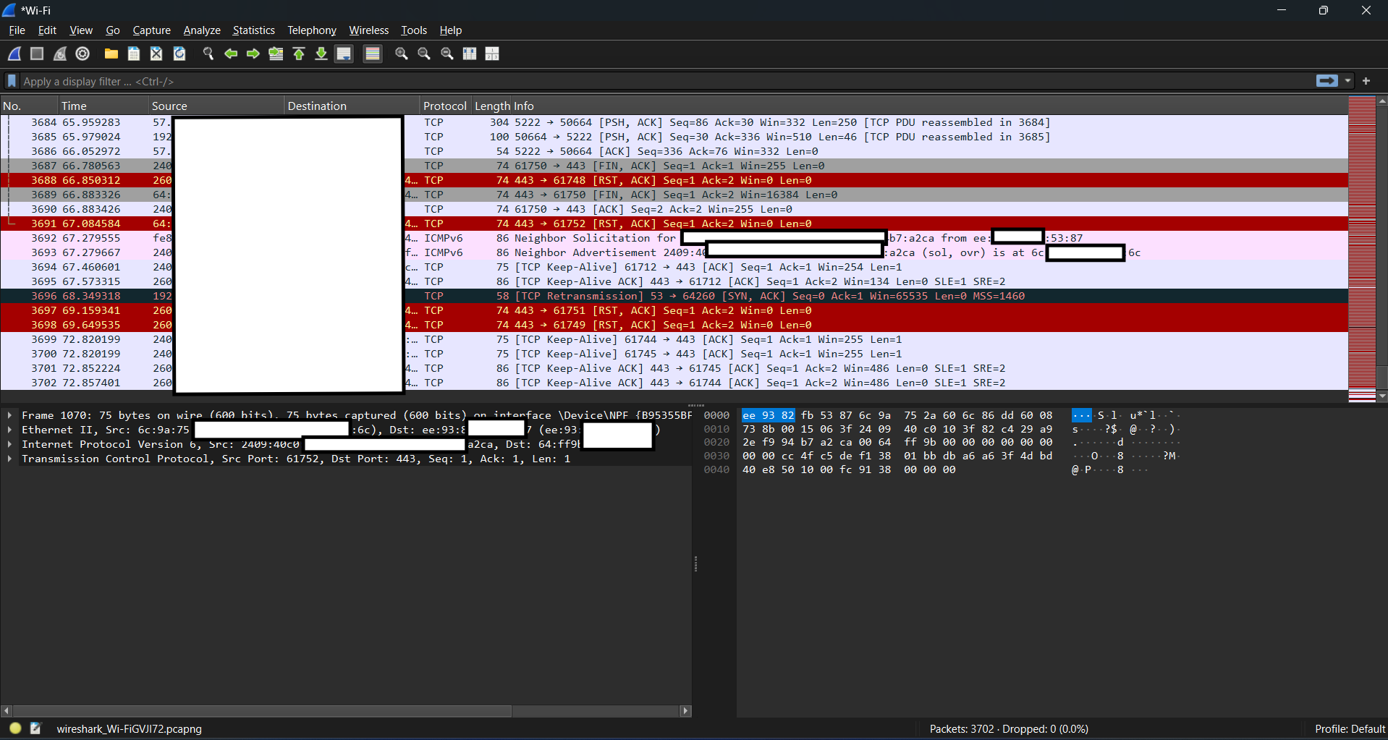

Total TCP-SYN Packets:

Filter: tcp.flags.syn == 1

Packets: 1006(27.2%)

Total TCP-ACK Packets:

Filter: tcp.flags.ack == 1

Packets: 1138(30.7%)

Total TCP-SYN + TCP-ACK Packets:

Filter: tcp.flags.ack == 1 && tcp.flags.syn == 1

Packets: 5(0.1%)

OBSERVATION:   
  
No Packets were dropped

3 TCP Retransmission making acknowledgement flag == 1

PORTS FOUND IN THE SCAN:

1. **Port:** 53

**State:** Open  
**Service:** Domain

**Purpose:** DNS Provider-> Used to map domain names to Specific IP

1. **Port:** 135

**State:** Open  
**Service:** msrpc (Microsoft Remote Procedure Call)

**Purpose:** A protocol allowing programs on different computers to communicate by executing procedures on the other machine, essentially enabling distributed computing within a network

1. **Port:** 139

**State:** Open  
**Service:** netbios-ssn

**Purpose:** Used for file and printer sharing over NetBIOS (SMBv1) in Windows

1. **Port:** 445

**State:** Open  
**Service:** microsoft-ds

**Purpose:** Used for file and printer sharing (SMBv2/v3) in Windows